EX NO: 7 | Monitoring HTTP and HTTPS packets using Wireshark
DATE:18/08/26

Objectives
- To capture and analyze HTTP packets using Wireshark and observe the transmission of data over an unsecured communication channel.
- To capture and analyze HTTPS packets using Wireshark and study the role of TLS encryption in securing web traffic and protecting transmitted data.

Software Requirements
  - Wireshark
  - Web Browser (Google Chrome/Mozilla Firefox)
  - Internet Connection

Websites Used
HTTP Website http://testaspnet.vulnweb.com/login.aspx

HTTPS Website https://arms.sse.saveetha.com/

Theory
HTTP (Hypertext Transfer Protocol)
HTTP is a protocol used for communication between web browsers and web servers. It transfers data in plaintext and does not provide encryption. As a result, transmitted information can potentially be viewed through packet monitoring tools.

HTTPS (Hypertext Transfer Protocol Secure)

HTTPS is the secure version of HTTP. It uses TLS (Transport Layer Security) to encrypt data exchanged between the client and the server. The encryption protects sensitive information such as usernames and passwords from unauthorized access.

Procedure
Part A: Monitoring HTTP Traffic
Step 1: Open Wireshark and select the active network interface. Step 2: Click Start Capturing Packets.
Step 3: Open a web browser and access: http://testaspnet.vulnweb.com/login.aspx Step 4: Enter sample credentials: Username : student
Password : admin123
Step 5: Click the Login button.
Step 6:Return to Wireshark and stop packet capture. Step 7: Apply the following filter: http
Step 8: Observe:
  - HTTP GET requests
  - HTTP POST requests
  - Request headers
  - Response headers
  - Form submission details

Part B: Monitoring HTTPS Traffic
Step 1: Start a new Wireshark capture session. Step 2: Open a web browser and access: https://arms.sse.saveetha.com/
Step 3: Log in using authorized credentials.

Step 4: Stop packet capture. Step 5: Apply the filter: tls Step 6: Observe:
  - Client Hello
  - Server Hello
  - TLS Handshake
  - Certificate Exchange
  - Encrypted Application Data
Step 7: Verify that login credentials are not visible.

Output:
Objective 1: HTTP Traffic Analysis

Username entered | Password entered | Username detected | Password detected
Lokesh | 2293 | Lokesh | 2293
Anbarasan | 2007 | Anbarasan | 2007

Objective 2: HTTPS Traffic Analysis

Username entered | Password entered | Username detected | Password detected
Lokesh | 2293 | Lokesh | 2293
Anbarasan | 2007 | Anbarasan | 2007

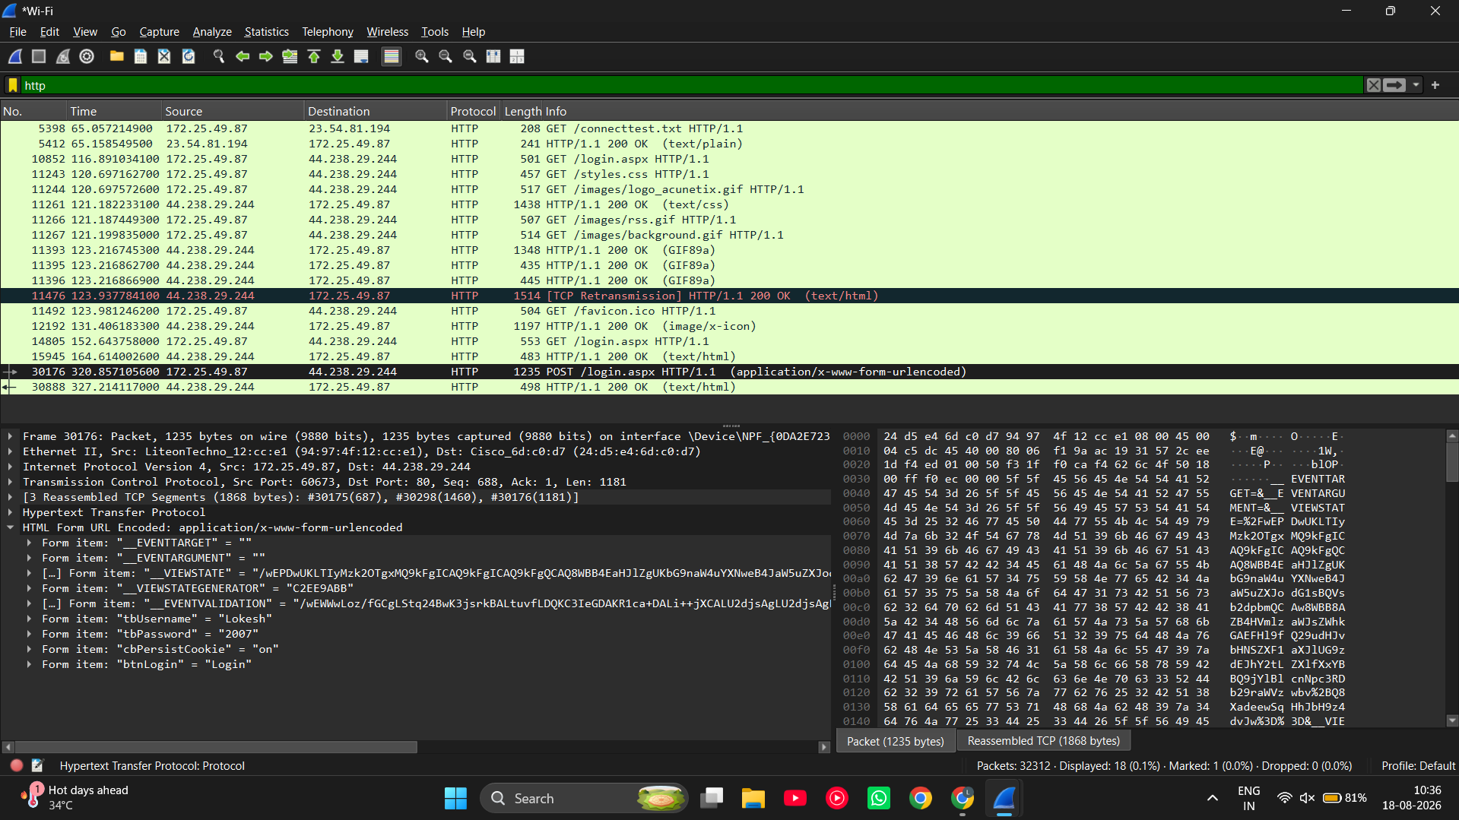

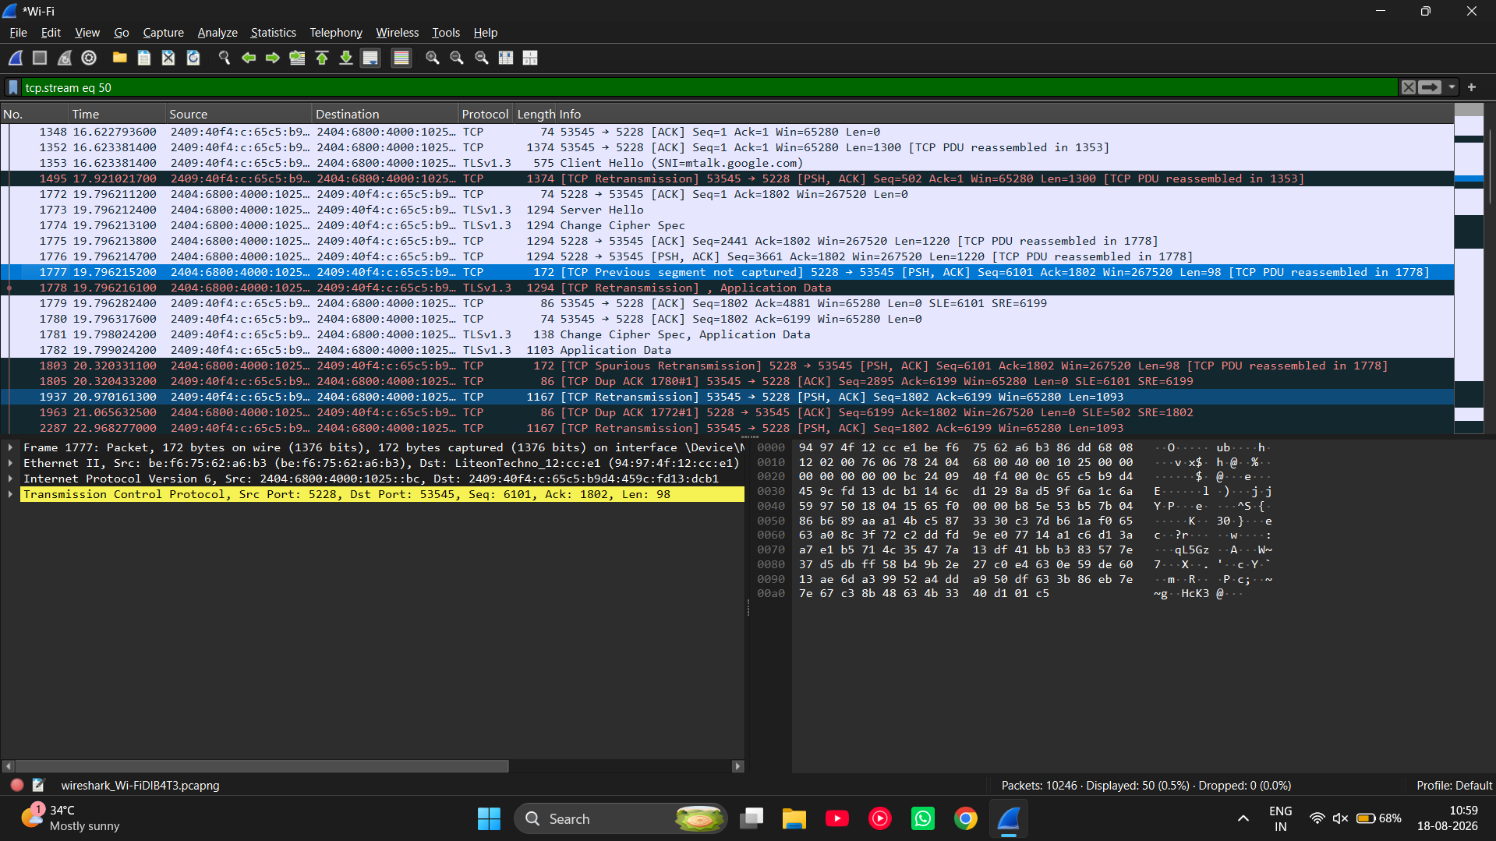

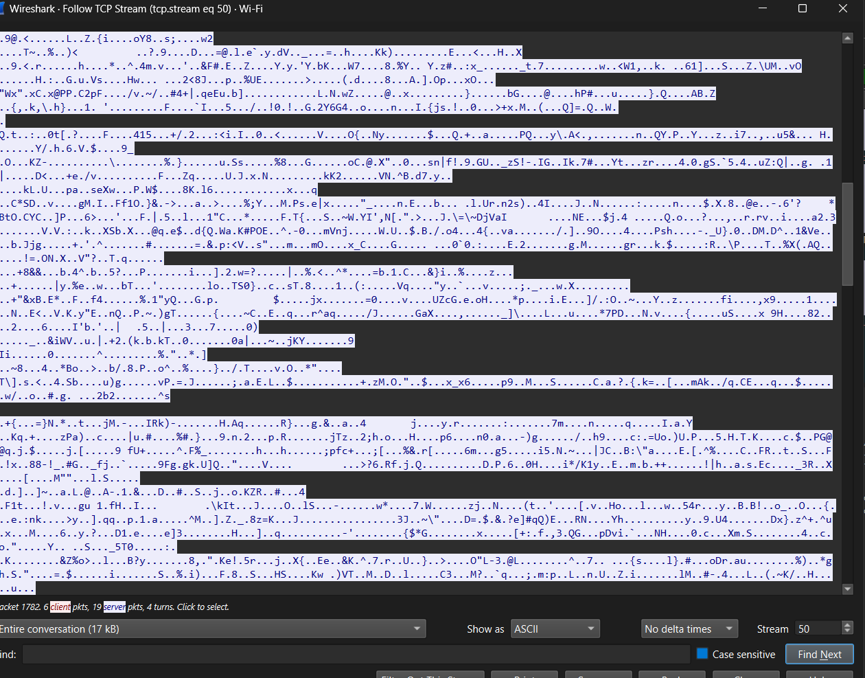

Result
Objective 1: HTTP Traffic Analysis
HTTP traffic was successfully captured and analyzed using Wireshark. The HTTP requests and responses were visible in plaintext, allowing the transmitted data and packet contents to be inspected. This demonstrated that HTTP does not provide encryption for web communications.

Objective 2: HTTPS Traffic Analysis
HTTPS traffic was successfully captured and analyzed using Wireshark. The TLS handshake and encrypted application data were observed, while sensitive information such as usernames and passwords remained protected and unreadable. This demonstrated the effectiveness of TLS encryption in securing web communications.

Test Case Question 1
Implement the specified network setup and analyze HTTP traffic using Wireshark.

Case 1
  - Number of PCs: 1
  - Number of Switches: 1
  - Number of Web Servers: 1
  - Protocol: HTTP
  - Packet Analyzer: Wireshark
  - Website: http://testaspnet.vulnweb.com/login.aspx

Tasks
- Configure the network connectivity and access the HTTP website from the client PC.
- Capture HTTP packets using Wireshark and identify HTTP GET and POST requests.
- Analyze the captured packets and observe the transmitted data exchanged between the client and the web server.

Test Case Question 2
Implement the specified network setup and analyze HTTPS traffic using Wireshark. Case 2
  - Number of PCs: 1
  - Number of Switches: 1
  - Number of Web Servers: 1
  - Protocol: HTTPS
  - Packet Analyzer: Wireshark
  - Website: https://www.gmail.com/

Tasks
- Configure the network connectivity and access the HTTPS website from the client PC.
- Capture HTTPS packets using Wireshark and identify the TLS handshake process.
- Analyze the captured packets and compare the visibility of transmitted data with HTTP traffic to verify the effect of TLS encryption.

